Arrays

1. Array Initialization and Manipulation:
   1. Create an array of 5 numbers.
   2. Add a number to the end of the array.
   3. Remove the first number from the array.
   4. Print the final array.

**Code:**

let number =[1,2,3,4,5]

number.push(6)

number.shift()

console.log(number)

**output:**

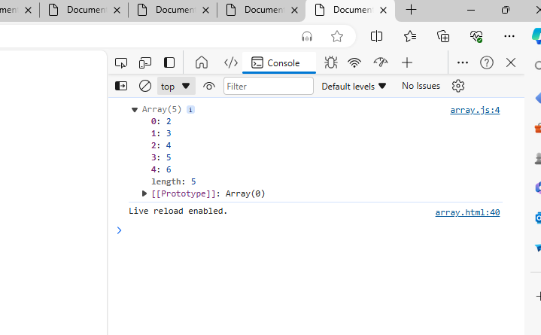

1. String Lengths in Array:
   1. Write a function that takes an array of strings and returns an array of their lengths.

**Code:**

function string(arry){

    let length=[]

    for(i=0;i<arry.length;i++){

        length.push(arry[i].length)

    }

    console.log(length)

}

let array=["sony","sharvani","swetha"]

string(array)

**output:**

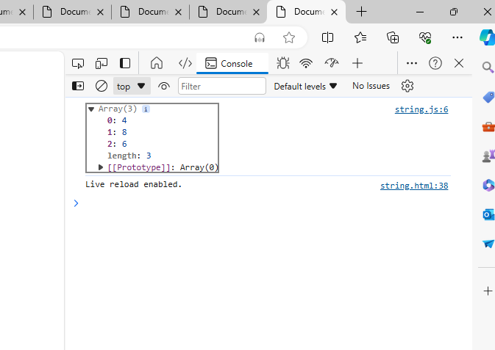

1. Filter Even Numbers:
   1. Write a function that takes an array of numbers and returns a new array containing only the even numbers.

**Code:**

function even(number){

    for(i=1;i<number.length;i++){

        if(i%2==0){

            console.log("even number",i);

        }

    }

}

let str=[1,2,3,4,5,6,7,8,9];

even(str);

**output:**

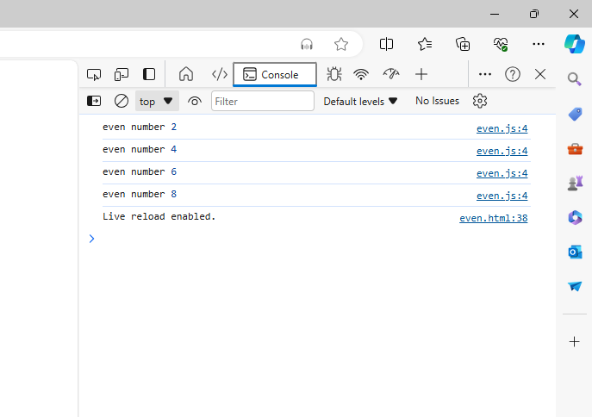

1. Reverse Strings:
   1. Write a function that takes an array of strings and returns a new array with each string reversed.

**Code:**

function reverse(arry){

   let newarry=[];

   for(i=0;i<arry.length;i++){

    let newstring="";

    for(str=arry[i].length-1;str>=0;str--){

        newstring+=arry[i][str];

    }

    newarry.push(newstring);

   }

   console.log(newarry);

}

let array=["sony","sharvani","swetha"];

reverse(array);

**output:**

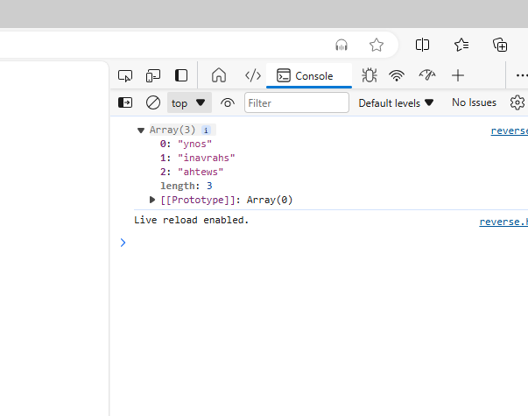

1. Sum of Array Elements:
   1. Write a function that takes an array of numbers and returns the sum of all the numbers.

**Code**:

function sum(number){

    let sum=0;

    for(i=0;i<=number.length;i++){

        sum+=i;

    }

    console.log(sum);

}

let array=[1,2,3,4,5,6,7,8];

sum(array);

**output:**

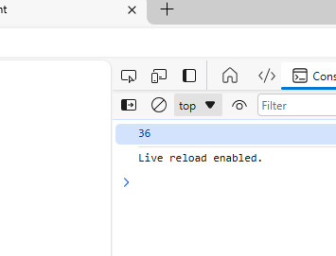

1. Find Longest String:
   1. Write a function that takes an array of strings and returns the longest string.

**Code:**

function string(number){

    let longest="";

    for(i=0;i<number.length;i++){

        if(number[i].length>longest.length){

            longest=number[i];

        }

    }

    console.log(longest);

}

let srt=["sony","sharvani","raju"];

string(srt);

**output:**

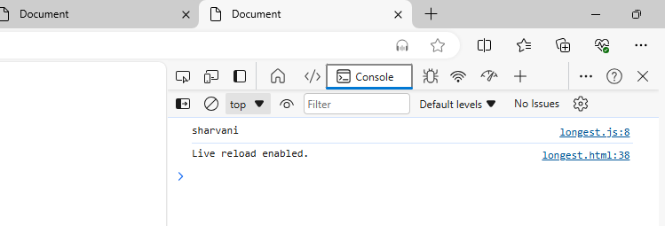

1. String Contains Character:
   1. Write a function that takes an array of strings and a character, and returns an array of strings that contain that character.

**Code:**

function array(number,char){

    let newarray=[];

    for(i=0;i<number.length;i++){

        if(number[i].includes(char)){

            newarray.push(number[i]);

        }

    }

    console.log(newarray);

}

let sTr=["sharvani","greemus","sony"];

let Ast="v";

array(sTr,Ast);

**output:**

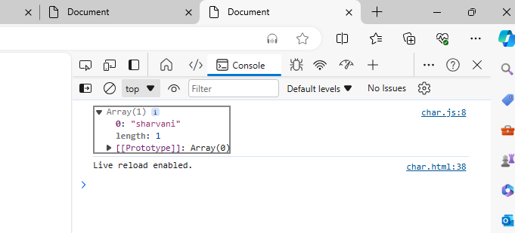

1. Concatenate Array of Strings:
   1. Write a function that takes an array of strings and returns a single string that is the concatenation of all the strings.

**Code:**

function array(number){

    let newstring="";

    for(i=0;i<number.length;i++){

        newstring=newstring.concat(number[i]);

    }

    console.log(newstring);

}

let Ast=["sharvani","reddy","palla"];

array(Ast)

**output:**

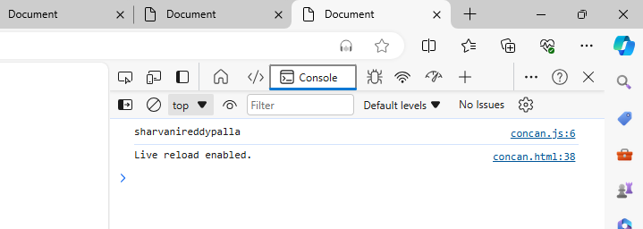

1. Capitalize First Letter:
   1. Write a function that takes an array of strings and returns a new array with the first letter of each string capitalized.

**Code:**

function array(number){

    let newarray=[];

    for(i=0;i<number.length;i++){

        let stR=number[i].charAt(0).toUpperCase()+number[i].slice(1);

        newarray.push(stR);

    }

    console.log(newarray);

}

let sTr=["sharvani","greemus","tony"];

array(sTr);

**output:**

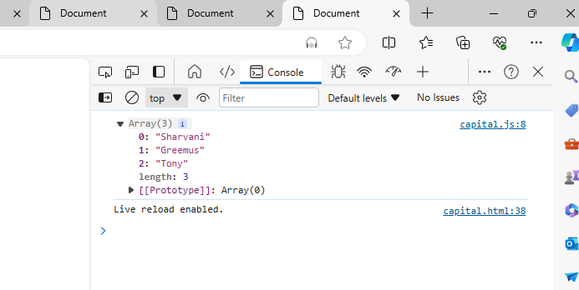

1. Flatten Nested Arrays:
   1. Write a function that takes a nested array (an array of arrays) and returns

**Code:**

function flatArray(arr) {

    let res = arr.flat(3);

    console.log(res);

  }

  let array = [1, 2, [3, 4, [5, 6, 7, [8, 9]]]];

  flatArray(array);

**output:**

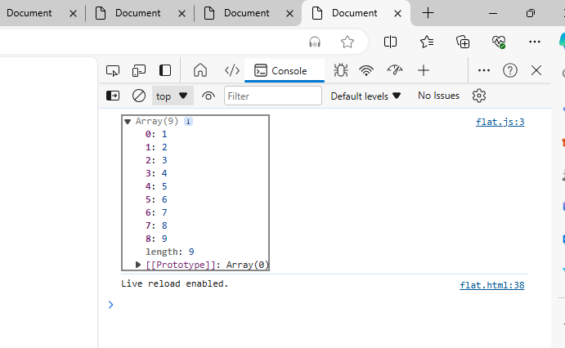

1. Count Occurrences:
   1. Write a function that takes an array of strings and returns an object where the keys are the strings and the values are the number of times each string appears in the array.

**Code:**

function countOccurance(x, y) {

  return x.reduce((accumulator, ele) => {

    let accumulatorCount = ele === y ? 1 : 0;

    return accumulator + accumulatorCount;

  }, 0);

}

let array = [1, 2, 3, 4, 3, 4, 6, 3, 7, 3, 8];

let res = countOccurance(array, 3);

console.log(res);

**output:**

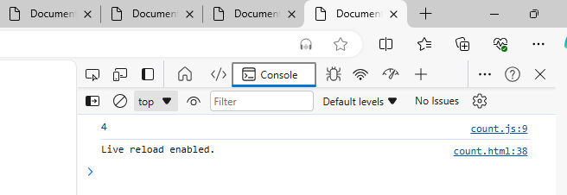

1. Remove Duplicates:
   1. Write a function that takes an array of numbers and returns a new array with all duplicate elements removed.

**Code**:

function duplicates(number){

     let removeduplicates=[...new Set(number)];

    console.log(removeduplicates);

}

let array=[1,2,3,4,3,5,5,6,7,4,6,6,];

duplicates(array)

**output:**

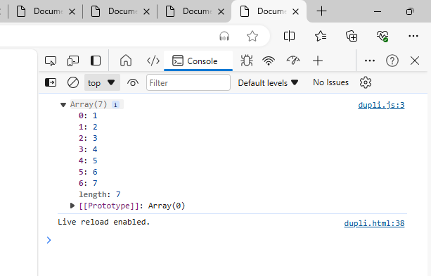

1. Find Index of String:
   1. Write a function that takes an array of strings and a string, and returns the index of the string in the array.

**Code:**

function array(number,count){

    let result=number. indexOf(count);

    console.log(result);

}

let array1=[1,2,3,4];

array( array1,3);

array(array1,6)

**output:**

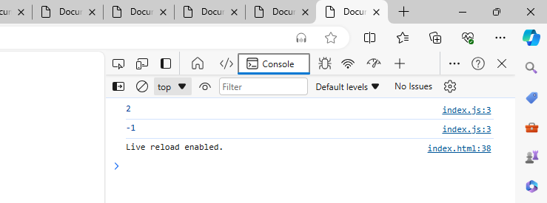

1. Sort Strings Alphabetically:
   1. Write a function that takes an array of strings and returns a new array with the strings sorted alphabetically.

**Code**:

function sortAlpha(arr) {

  return arr.sort();

}

let array = ["rithu","sony","aqua","quaula"];

console.log(sortAlpha(array));

**output**:

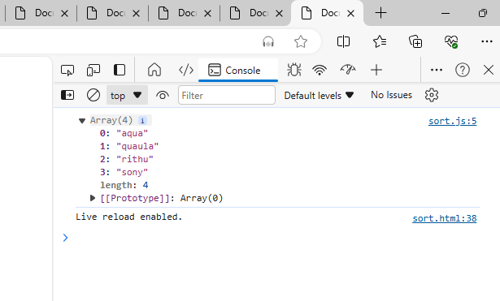

1. Sum of Square of Numbers:
   1. Write a function that takes an array of numbers and returns the sum of the squares of those numbers.

**Code:**

function sumOfSquares(arr) {

    let sum = 0;

    for (let i = 0; i < arr.length; i++) {

      let res = arr[i] * arr[i];

      sum += res;

    }

    return sumofsquares = {sum};

  }

  let array = [6,7,9,3];

  console.log(sumOfSquares(array));

**output:**

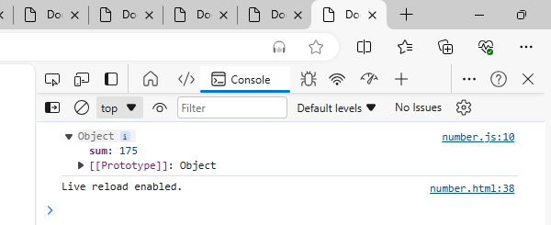

1. Convert Strings to Uppercase:
   1. Write a function that takes an array of strings and returns a new array with all the strings converted to uppercase.

**Code:**

function arrayStrUpper(strArr) {

    let strUpper = [];

    for (i = 0; i < strArr.length; i++) {

      let res = strArr[i].toUpperCase();

      strUpper.push(res);

    }

    return strUpper;

  }

  let array = ["sony", "reddy", "sharvani"];

  console.log(arrayStrUpper(array));

**output:**

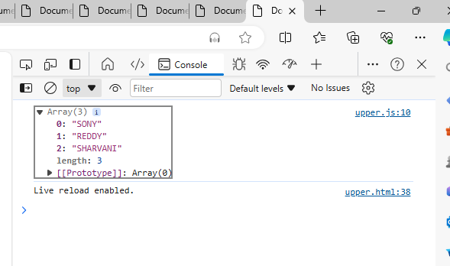

1. Find Common Elements:
   1. Write a function that takes two arrays of numbers and returns a new array containing the common elements from both arrays.

**Code:**

function common(x, y) {

    let cArray = [];

    for (i = 0; i <= x.length; i++) {

      if (y.includes(x[i])) {

        cArray.push(x[i]);

      }

    }

    return commonarray = {cArray};

  }

  let arr1 = [1,2,3,4,5,6,7,8,9];

  let arr2 = [6,7,8,3];

  console.log(common(arr1, arr2));

**output:**

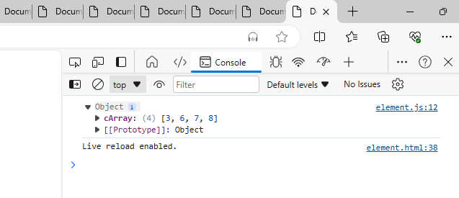

1. Remove Falsy Values:
   1. Write a function that takes an array and returns a new array with all falsy values (false, 0, "", null, undefined, NaN) removed.

**Code**:

function removeFalse(arr) {

    let truthyValues = [];

    for (let ele of arr) {

      if (!!ele) {

        truthyValues.push(ele);

      }

    }

    return truthyValues;

  }

  let array = [false, 0, "", null, undefined, NaN, 1, true];

  console.log(removeFalse(array));

**output:**

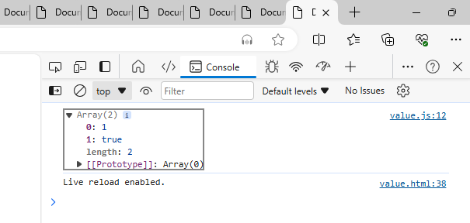

1. Find Unique Characters:
   1. Write a function that takes a string and returns an array of unique characters in the string.

**Code**:

function unique(str) {

    let res = str.split("");

    return res;

  }

  let str = "sharvani";

  console.log(unique(str));

**output:**

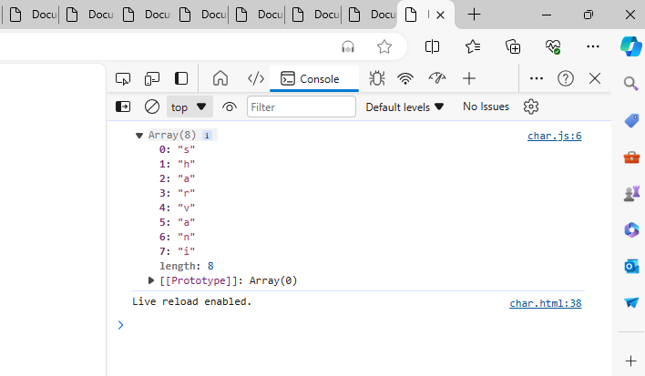

1. Merge and Sort Arrays:
   1. Write a function that takes two sorted arrays of numbers and returns a single sorted array that combines both arrays.

**Code:**

function merge(arr1, arr2) {

    let res = arr1.concat(arr2).sort();

    return mergeandsort = {res};

  }

  let array1 = [1,2,3,4,3];

  let array2 = [1,2,3,4,5,6,7,3,2,1];

  console.log(merge(array1, array2));

**output:**

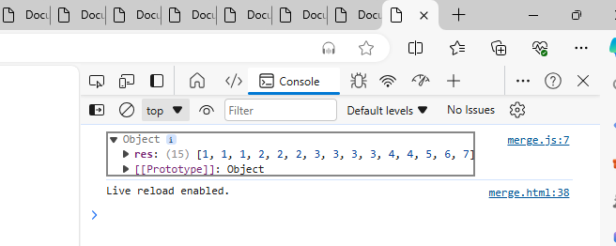

1. Count Occurrences:
   1. Write a function that takes an array of strings and returns an object where the keys are the strings and the values are the number of times each string appears in the array.

**Code**:

function countOccurance(x, y) {

    return x.reduce((accumulator, ele) => {

      let accumulatorCount = ele === y ? 1 : 0;

      return accumulator + accumulatorCount;

    }, 0);

  }

  let array = [1, 2, 3, 4, 3, 4, 6, 3, 7, 3, 8];

  let res = countOccurance(array, 3);

  console.log(res);

**output:**

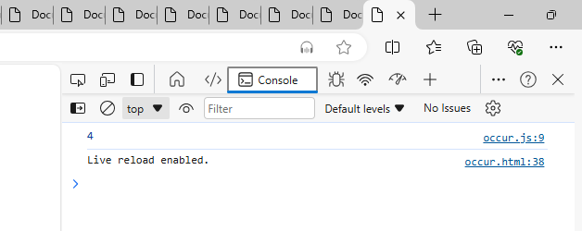

1. Remove Duplicates:
   1. Write a function that takes an array of numbers and returns a new array with all duplicate elements removed.

**Code:**

function duplicates(number){

    let removeduplicates=[...new Set(number)];

   console.log(removeduplicates);

}

let array=[1,2,3,4,3,5,5,6,7,4,6,6,];

duplicates(array)

**output:**

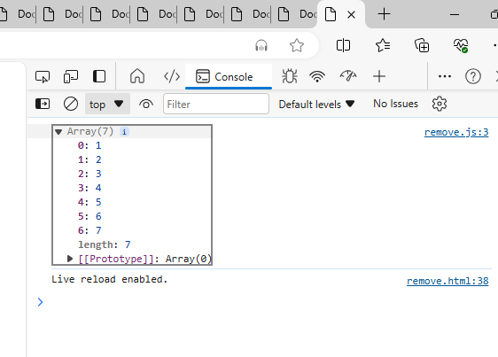

1. Find Index of String:
   1. Write a function that takes an array of strings and a string, and returns the index of the string in the array. If the string is not found, return -1.

**Code:**

function array(number,count){

    let result=number. indexOf(count);

    console.log(result);

}

let array1=[1,2,3,4];

array( array1,3);

array(array1,6)

**output:**

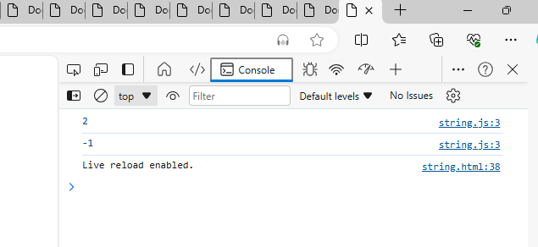

1. Sort Strings Alphabetically:
   1. Write a function that takes an array of strings and returns a new array with the strings sorted alphabetically.

**Code**:

function sortAlpha(arr) {

    return arr.sort();

  }

  let array = ["rithu","sony","aqua","quaula"];

  console.log(sortAlpha(array));

**output:**

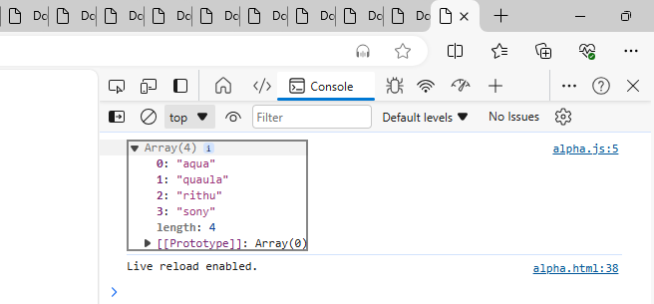

1. Sum of Square of Numbers:
   1. Write a function that takes an array of numbers and returns the sum of the squares of those numbers.

**Code**:

function sumOfSquares(arr) {

    let sum = 0;

    for (let i = 0; i < arr.length; i++) {

      let res = arr[i] * arr[i];

      sum += res;

    }

    return sumofsquares = {sum};

  }

  let array = [1,2,3,3,];

  console.log(sumOfSquares(array));

**output**:

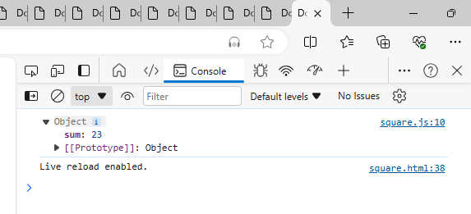

1. Convert Strings to Uppercase:
   1. Write a function that takes an array of strings and returns a new array with all the strings converted to uppercase.

**Code**:

function arrayStrUpper(strArr) {

    let strUpper = [];

    for (i = 0; i < strArr.length; i++) {

      let res = strArr[i].toUpperCase();

      strUpper.push(res);

    }

    return strUpper;

  }

  let array = ["sony", "reddy", "sharvani"];

  console.log(arrayStrUpper(array));

**output:**

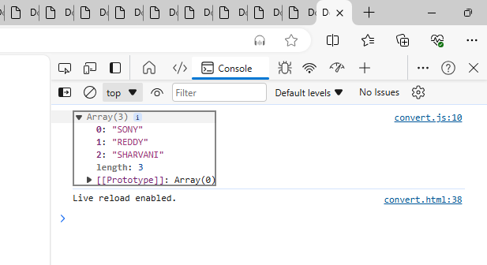

1. Find Common Elements:
   1. Write a function that takes two arrays of numbers and returns a new array containing the common elements from both arrays.

**Code:**

function common(x, y) {

    let cArray = [];

    for (i = 0; i <= x.length; i++) {

      if (y.includes(x[i])) {

        cArray.push(x[i]);

      }

    }

    return commonarray = {cArray};

  }

  let arr1 = [1,2,3,4,5,6,7,8,9];

  let arr2 = [6,7,8,3];

  console.log(common(arr1, arr2));

**output:**

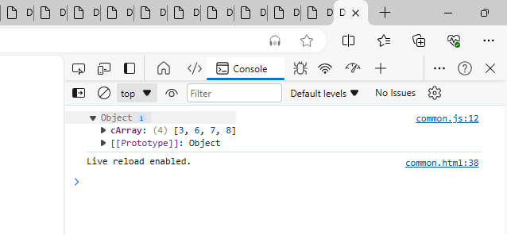

1. Remove Falsy Values:
   1. Write a function that takes an array and returns a new array with all falsy values (false, 0, "", null, undefined, NaN) removed.

**Code**:

function removeFalse(arr) {

    let truthyValues = [];

    for (let ele of arr) {

      if (!!ele) {

        truthyValues.push(ele);

      }

    }

    return truthyValues;

  }

  let array = [false, 0, "", null, undefined, NaN, 1, true];

  console.log(removeFalse(array));

**output:**

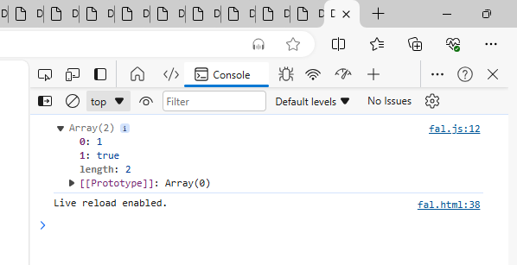

1. Find Unique Characters:
   1. Write a function that takes a string and returns an array of unique characters in the string.

**Code:**

function unique(str) {

    let res = str.split("");

    return res;

  }

  let str = "sharvani";

  console.log(unique(str));

**output:**

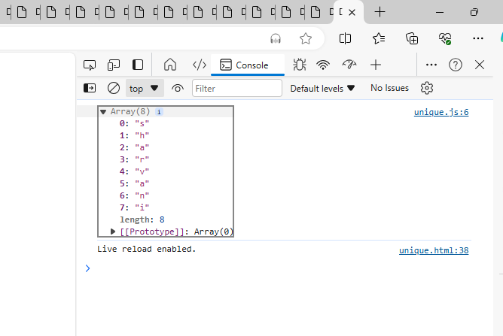

1. Merge and Sort Arrays:
   1. Write a function that takes two sorted arrays of numbers and returns a single sorted array that combines both arrays.

**Code**:

function merge(arr1, arr2) {

    let res = arr1.concat(arr2).sort();

    return mergeandsort = {res};

  }

  let array1 = [1,2,3,4,3];

  let array2 = [1,2,3,4,5,6,7,3,2,1];

  console.log(merge(array1, array2));

**output**:

